**Abstarct**

The given scenario can be achieved by dynamic content as it has capability to configure email based on the attribute and field value.

Also without code,SQL query and HTML we can create rule which will help in building dynamic email template and reengaging the existing customers seamlessly.

In given scenario the best persona will be built based on Recent Car Rental Duration field value. As this value is emphasizing more on the customers behavior and trust on the car rental firm also with help of this value we can get to know how user experience was and how they want to reconnect with rental firm.

**Use Cases**

**Step 1:**

Create send able data extension and stored existing customer information on it.

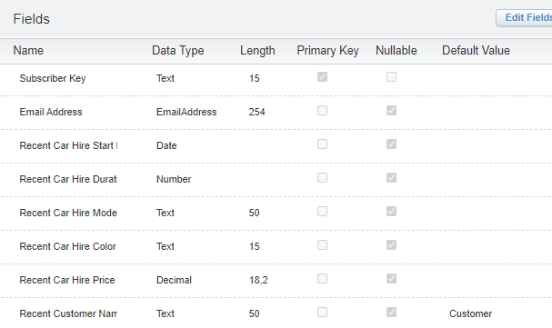

**Step 2:**

Create user persona based on the user behavior which will help in reengaging the existing customers.

Recent car hire duration field will help in building user persona. As this field describes users behavior and trust on rental firm.

In this scenario lot of user persona can be created based on multiple fields like:

Recent car hire duration, Recent car hire model.

So based on this we can create different rules in dynamic content and segment the user based on their behavior. This approach will provide seamless user experience to end user so that they can easily reconnect with rental firm.

**First Criteria**: **Recent car hire duration is greater than 15 days**.

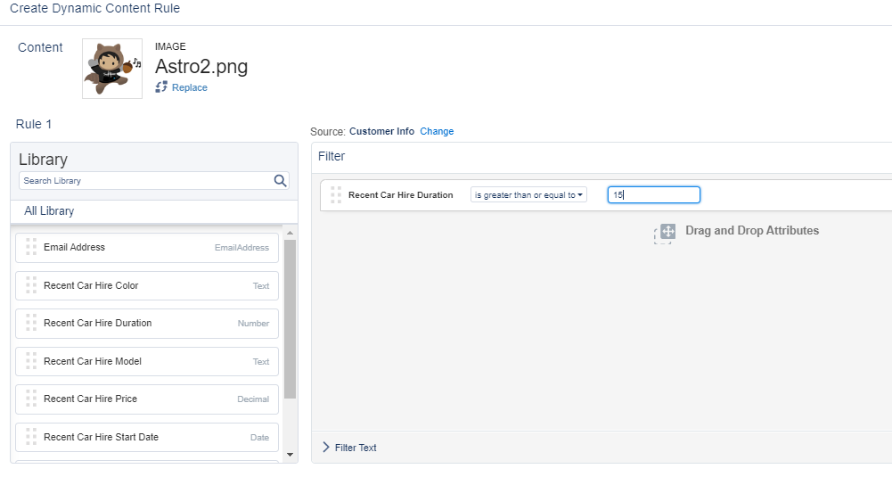

**The users which fulfill this criterion will consider as loyal member as they have shown trust on rental firm.**

Based on that will create content for this user which will show them some good model of the car with compelling rent prices and unlimited mileage. Also, we can provide some good deal to engage them for long term rental by comparing with their previous rental price and include some overall rental off.

**Just of example:**

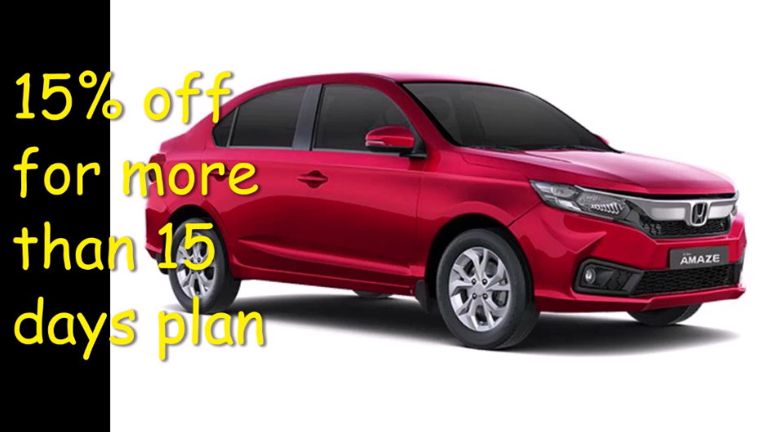

**Second Criteria**: **Recent car hire duration is less than equal to 7 days AND Recent car hire duration is greater than 1.**

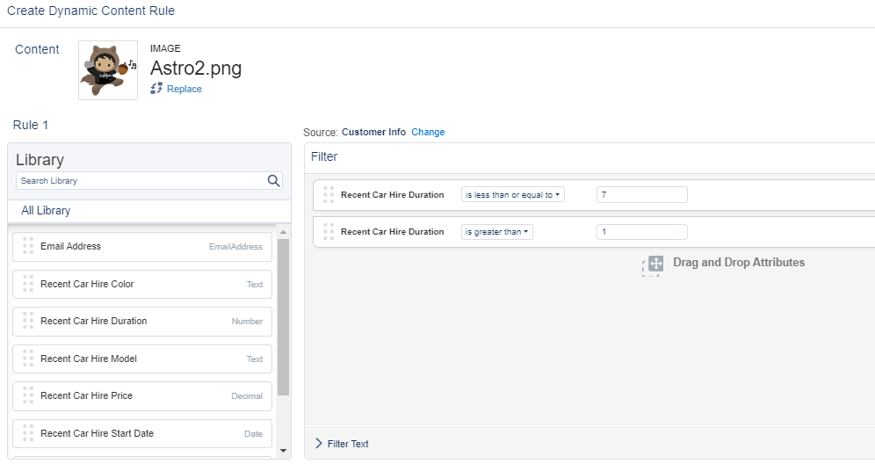

As these are the users who is connected with firm and shown their interest. As their behavior is not static with rental car model , rental car duration and rental car color so for these kind of users we need to give offers in all aspects so that they can reengage easily . Like we can provide some of the car model which is high and medium price also some of the deals like **10% off for more than 3 days** and so on.

**Just of example:**

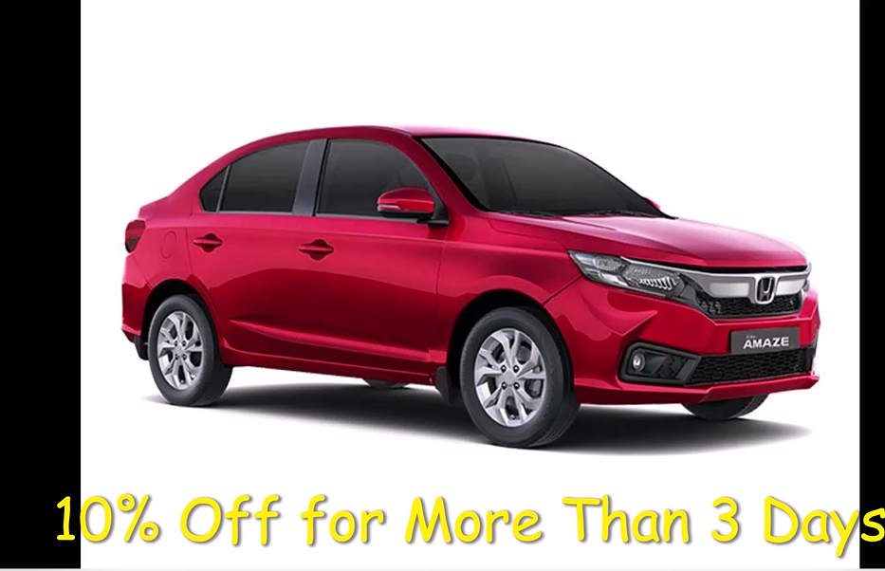

**Third Criteria**: **Recent car hire duration is equal to 1 day AND Recent car hire Model is the highest one which rental firm is providing.**

By this persona car rental firm is sure about user behavior as they are not worry about rental price they are more intend towards branding /models. These kinds of customers prefer luxury car so rental car firm should provide better deal on expensive models.



**Default criteria: All the offers will be shown to reengaging the existing customers.**

**As the personas are not constant so better to provide all deals which are available so that customers can reengage with firm based on their need.**



**Additional Points To Consider:**

**We can provide users to select their color preference in email using interactive form.**

